**EXPERIMENT-01**

**The Count of Deleted Files using Forensic Tools**

**Aim of the Experiment**:

Identify the count of deleted files using forensic tools

**Procedure:**

**Step 1**: Download Recovermyfile tool   
URL: [Data recovery software download: Get Recover My Files here](https://getdata.com/recovermyfiles/data-recovery-software-download.php)

**Step 2:** Setup from the exe file downloaded

**Step 3**: Select the drive to recover the count of the deleted files

**Step 4:** Start the recover process

**Step 5:** Wait for the scanning process to complete

**Step 6:** After the completion of the scanning process, the count of the deleted files can be found and analysed. (Fig 1)

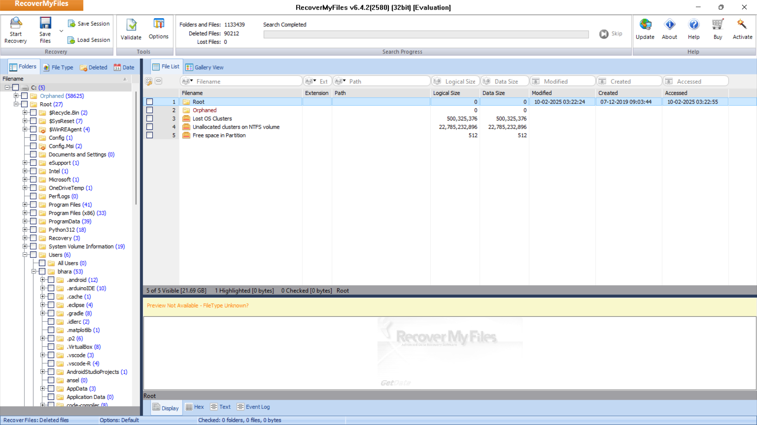

**Result:**

The experiment of Identifying the count of deleted files using forensic tools successfully executed.

**EXPERIMENT-02**

**Hiding and extracting a text file behind an image file.**

**Aim of the Experiment**:

To study the steps for hiding and extract any text file behind an image file using Command Prompt.

Any file like .rar .jpg .txt or any file can be merged inside another file. In a simple way, we shall learn how to hide a text file inside an image file using the Command Prompt.

**How to Hide the FILE?**

Suppose you have to hide a text file “A.txt” with the image file “B.jpg” and combine them in a new file as “C.jpg”. Where “C.jpg” is our output file which contains the text hidden in the image file.

Follow the steps:

1. copy the file need to hide, to desktop (for our tutorial let us assume the file to be "A.txt")
2. copy the image, within which you need to hide the file, to desktop (let it be "B.jpg")
3. now open the cmd: >ctrl+r >type: cmd and hit enter
4. in cmd first type the code as follows: >cd desktop NOTE: this code is for assigning the location on cmd to desktop
5. Now type the following code:

**copy /b B.jpg + A.txt C.jpg**

**Syntax:** *copy /b Name-of-file-containing-text-you-want-to-hide.txt + Name-of-initial- image.jpg Resulting-image-name.jpg*

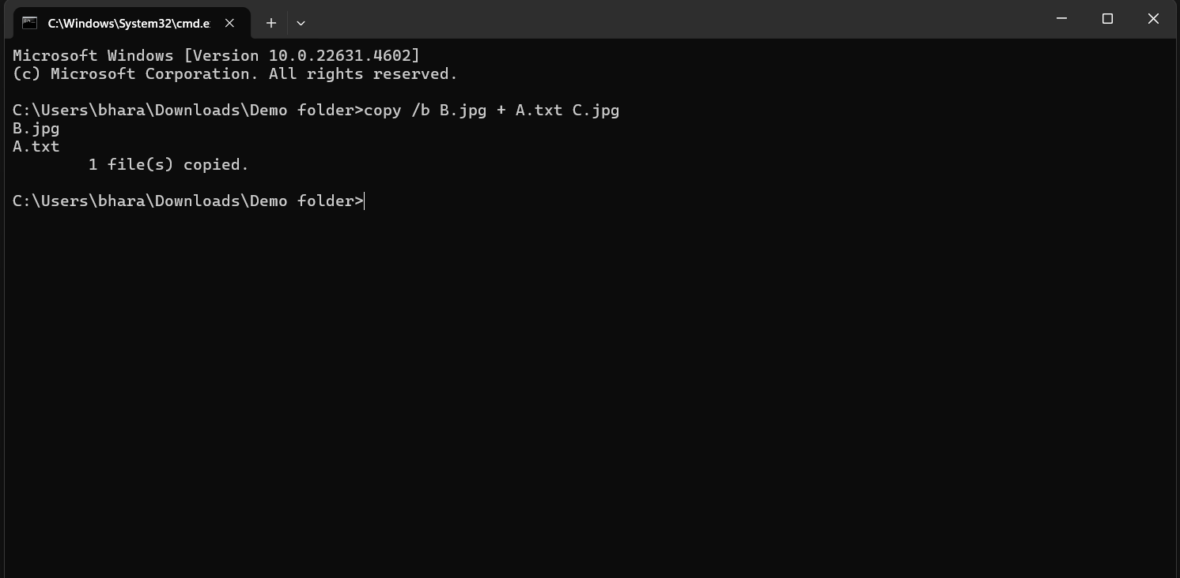

"C.jpg" is the output image inside this out image our file is hidden

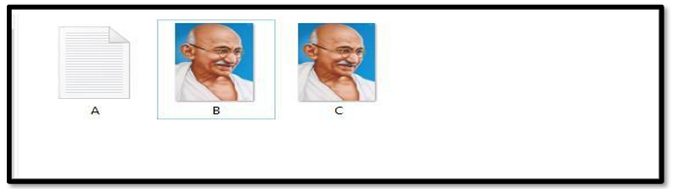

**How to retrieve the file?**

1. locate C.jpg file from where you want to retrieve text data
2. Right-click and open with notepad

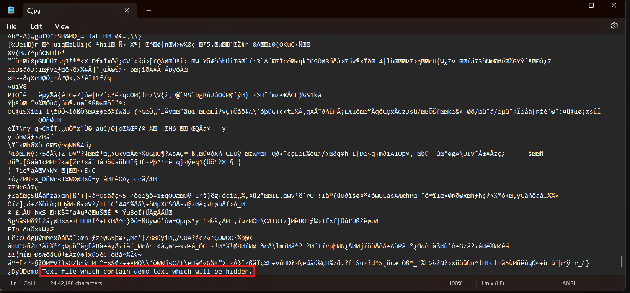

Done! Successfully opened! In the last of the notepad, you’ll find the content of the text file.

Hide A Message into Image:

1. Open Run command window by pressing win + r.
2. Open command prompt by typing cmd and press OK
3. Enter the directory where you have your files.
4. Then type the command: echo "Your Message">>"image.jpg"
5. Now the message is successfully hidden in the image file.
6. To view the message: Open with Notepad, at last, you’ll find the Your Message

**Result:**

The experiment has been successfully executed.

**EXPERIMENT-03**

**Hiding and extracting a text file behind an audio file.**

**Aim of the Experiment**:

To study the steps for hiding and extract any text file behind an Audio file using Command Prompt.

Any file like .rar .jpg .txt or any file can be merged inside another file. In a simple way, we shall learn how to hide a text file inside an image file using the Command Prompt.

**How to Hide the FILE?**

Suppose you have to hide a text file “A.txt” with the image file “sound.mp3” and combine them in a new file as “newfile.mp3”. Where “newfile.mp3” is our output file which contains the text hidden in the image file.

Follow the steps:

1. copy the file need to hide, to desktop (for our tutorial let us assume the file to be "A.txt")
2. copy the audio, within which you need to hide the file, to desktop (let it be "sound.mp3")
3. now open the cmd: >ctrl+r >type: cmd and hit enter
4. in cmd first type the code as follows: >cd desktop NOTE: this code is for assigning the location on cmd to desktop
5. Now type the following code:

**copy /b A.txt + sound.mp3 newfile.mp3**

**Syntax:** *copy /b Name-of-file-containing-text-you-want-to-hide.txt + Name-of-initial- audio.mp3 Resulting-audio-name.mp3*

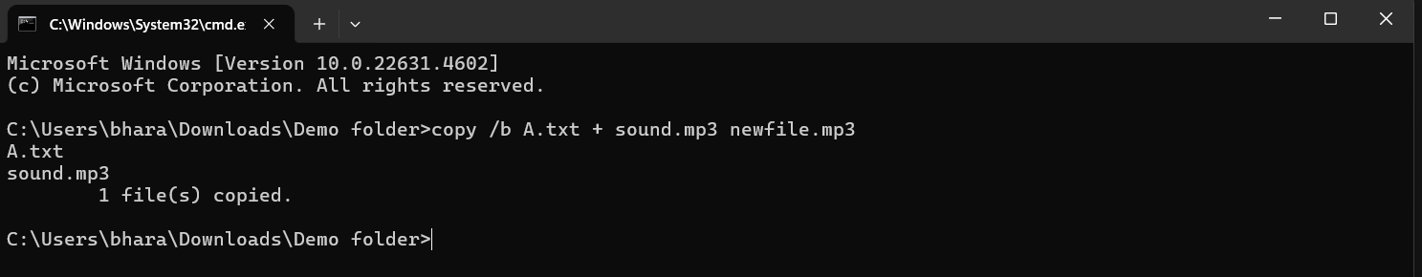

"newfile.mp3" is the output audio inside this out audio our file is hidden

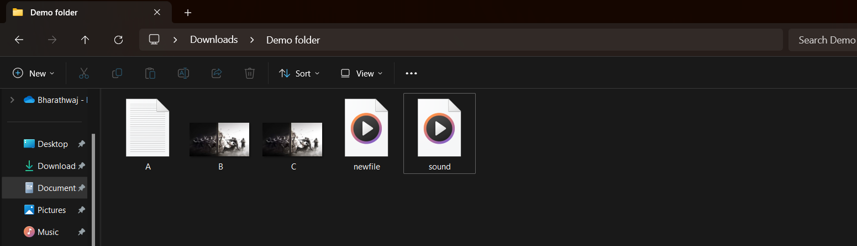

**How to retrieve the file?**

1. locate newfile.mp3 file from where you want to retrieve text data
2. Right-click and open with notepad

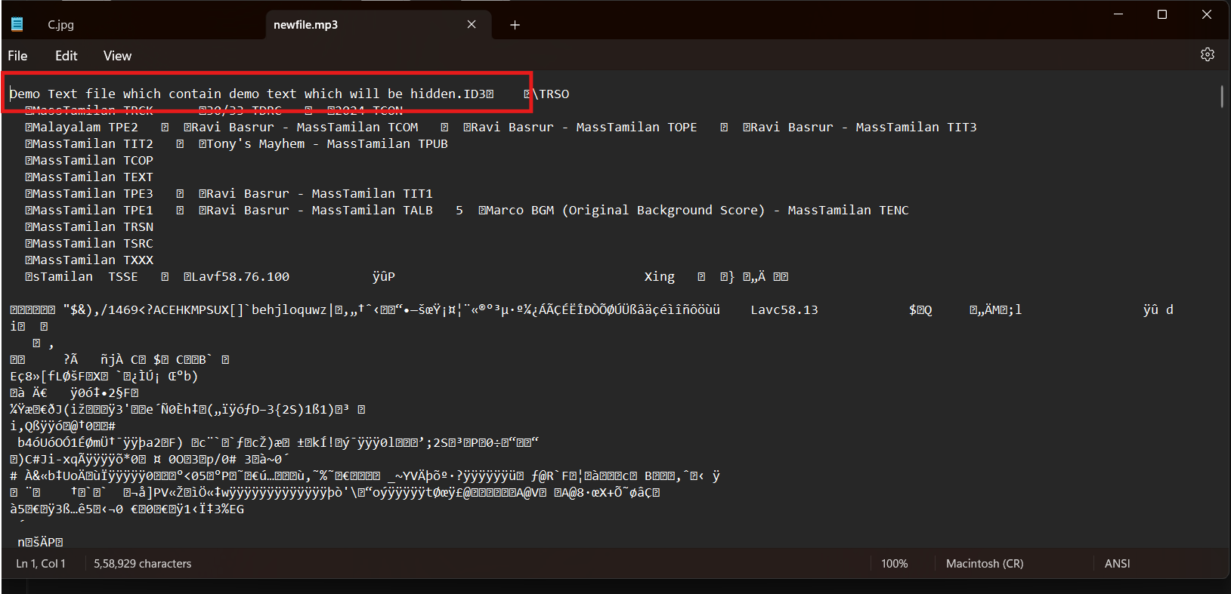

Done! Successfully opened! In the last of the notepad, you’ll find the content of the text file.

Hide A Message into Audio:

1. Open the Run command window by pressing win + r.
2. Open command prompt by typing cmd and press OK
3. Enter the directory where you have your files.
4. Then type the command: echo "Your Message">>"audio.mp3"
5. Now the message is successfully hidden in the audio file.
6. To view the message: Open with Notepad, at last, you’ll find the Your Message

**Result:**

The experiment has been successfully executed.

**EXPERIMENT-04**

**Extract Exchangeable image file format (EXIF) Data**

**Aim of the Experiment**:

How to Extract Exchangeable image file format (EXIF) Data from Image Files using Exif reader Software.

**Procedure:**

**Step 1**: Visit The given URL below  
 URL: [exifreader.com](https://www.exifreader.com/)

**Step 2:** Find an Appropriate image file

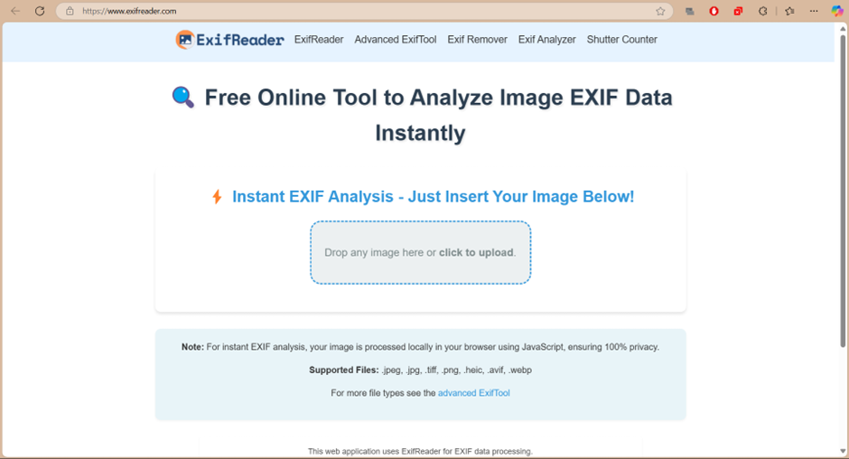

**Step 3**: Select the image file and upload the image file

**Step 4:** Analyse the exif features of the image

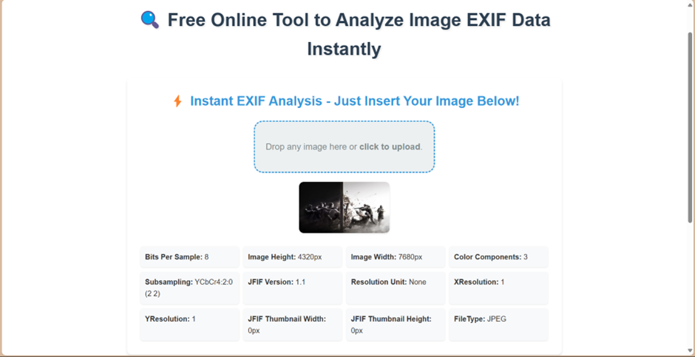

**Step 5:** After the completion of the analysing the image, you can find the result as the above image.

**Result:**

The experiment has been successfully executed.

**EXPERIMENT-05**

**Extract Chrome History using forensic tools**

**Aim of the Experiment**:

To Extract Chrome history using forensic tools and analyse them.

**Procedure:**

**Step 1**: Download Browsing History View tool   
URL:

<https://sourceforge.net/projects/browsinghistoryview/>

**Step 2:** Setup from the exe file downloaded

**Step 3**: Click run anyway when the below dialog box appears

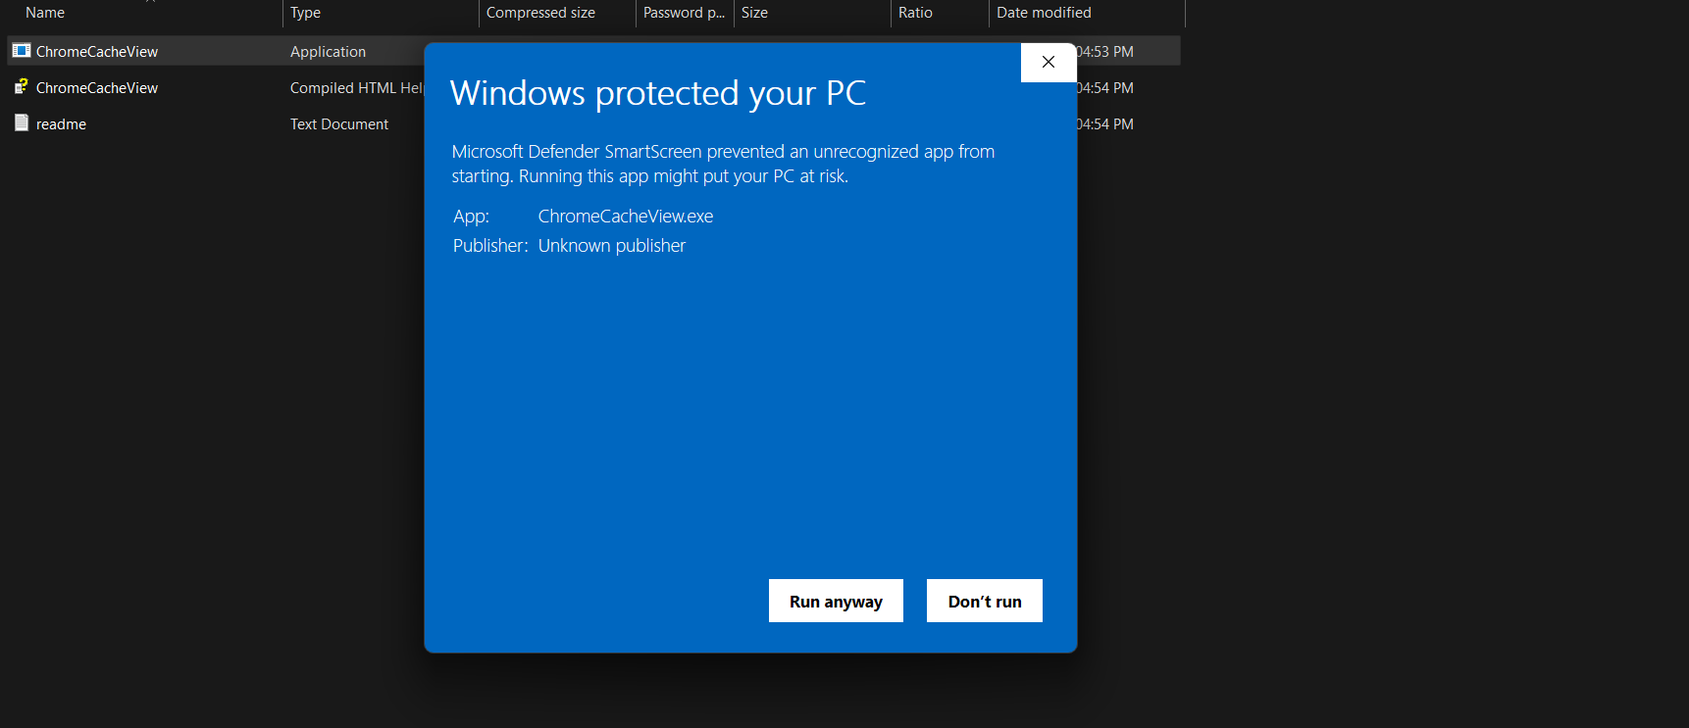

**Step 4:** Start the Browsing History View Tool

**Step 5:** Wait for the scanning process to complete

**Step 6:** After the completion of the scanning process, the chrome history view can be found and analysed.

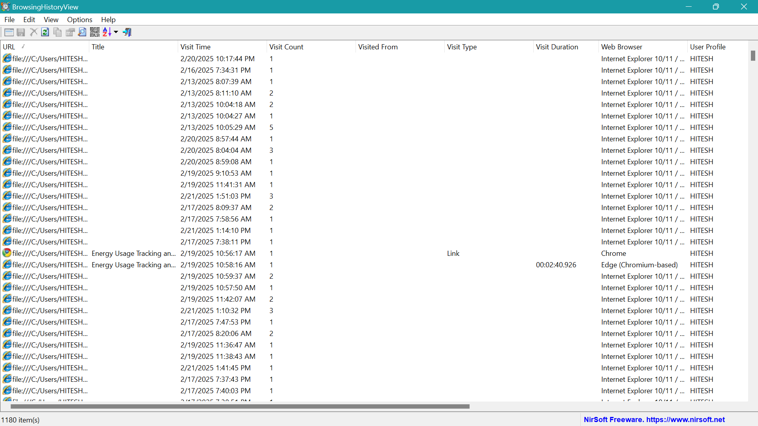

**Result:**

The experiment has been successfully executed

**EXPERIMENT-06**

**Extract Chrome cache using forensic tools**

**Aim of the Experiment**:

To Extract Chrome cache using forensic tools and analyse them.

**Procedure:**

**Step 1**: Download Chrome cache View tool   
URL: <https://sourceforge.net/projects/chromecacheview/>

**Step 2:** Setup from the exe file downloaded

**Step 3**: Click run anyway when the below dialog box appears



**Step 4:** Start the Chrome Cache View Tool

**Step 5:** Wait for the scanning process to complete

**Step 6:** After the completion of the scanning process, the chrome cache view can be found and analysed.

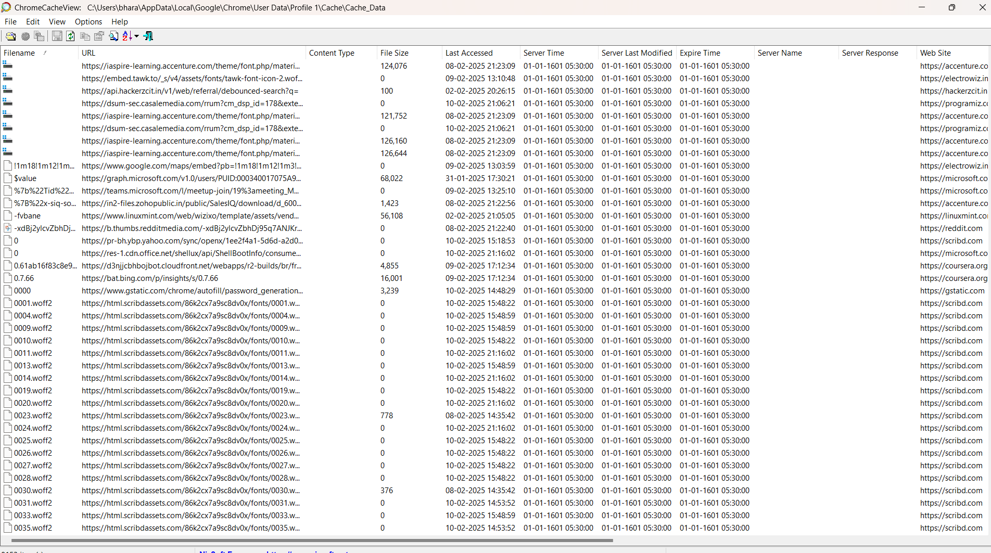

**Result:**

The experiment has been successfully executed

**EXPERIMENT-07**

**Extract last activity using forensic tools**

**Aim of the Experiment**:

To Extract the last activity view using forensic tools and analyse them.

**Procedure:**

**Step 1**: Download last activity view View tool   
URL: <https://www.softportal.com/en/lastactivityview/windows/software>

**Step 2:** Setup from the exe file downloaded

**Step 3**: Click run anyway when the below dialog box appears



**Step 4:** Start the last activity view View Tool

**Step 5:** Wait for the scanning process to complete

**Step 6:** After the completion of the scanning process, the last activity view can be found and analysed.

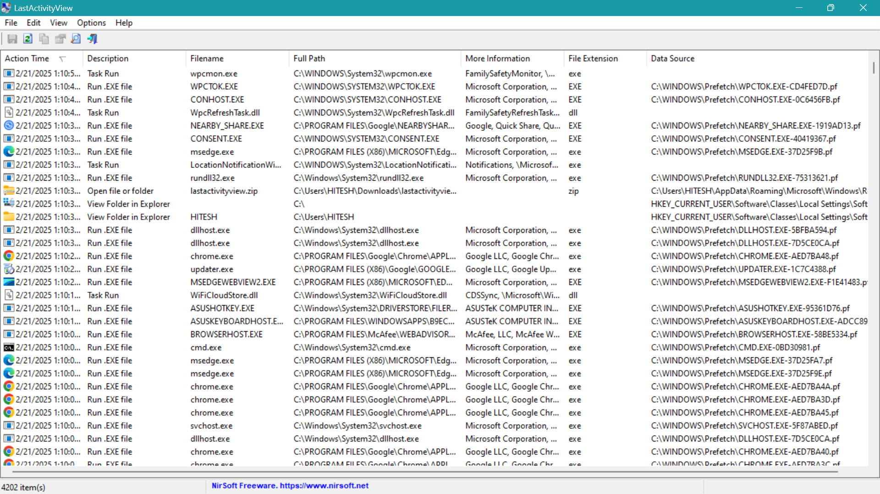

**Result:**

The experiment has been successfully executed

**EXPERIMENT-08**

**Extract USB devices using forensic tools**

**Aim of the Experiment**:

To Extract the connected external devices using forensic tools and analyse them.

**Procedure:**

**Step 1**: Download previous USB devices view tool   
URL: [USBDeview download | SourceForge.net](https://sourceforge.net/projects/usbdeview/)

**Step 2:** Setup from the exe file downloaded

**Step 4:** Start the USB devices view Tool

**Step 5:** Wait for the scanning process to complete

**Step 6:** After the completion of the scanning process, the USB devices view can be found and analysed.

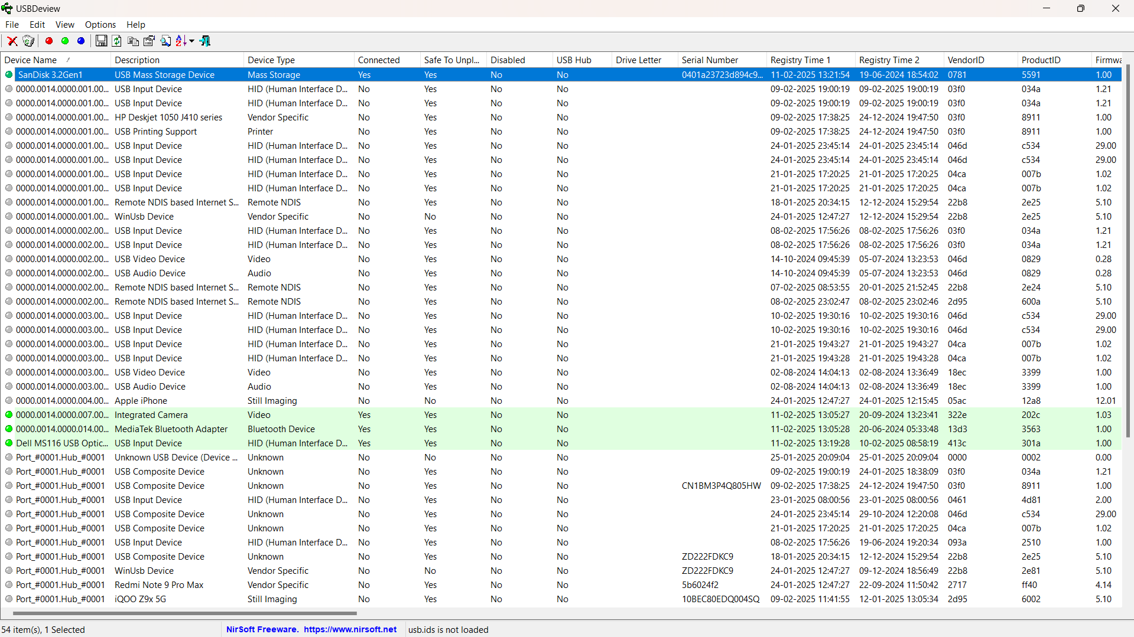

**Result:**

The experiment has been successfully executed

**EXPERIMENT 9**

**TRANSPORT LAYER PROTOCOL HEADER ANALYSIS USING WIRESHARK-TCP**

**Aim:** To analyze capturing of Transport layer protocol header analysis using Wire shark- TCP.

**SOFTWARE USED:** Wire shark network analyzer

**Procedure:**

1. Open wire shark.
2. Click on list the available capture interface.
3. Choose the wifi interface.
4. Click on the start button.
5. Active packets will be displayed.
6. Capture the packets & select any IP address from the source.
7. Click on the expression and select IPV4 →IP address source address in the field name.
8. Select the double equals (==) from the selection and enter the selected IP source address.
9. Click on the apply button.
10. All the packets will be filtered using the source address.

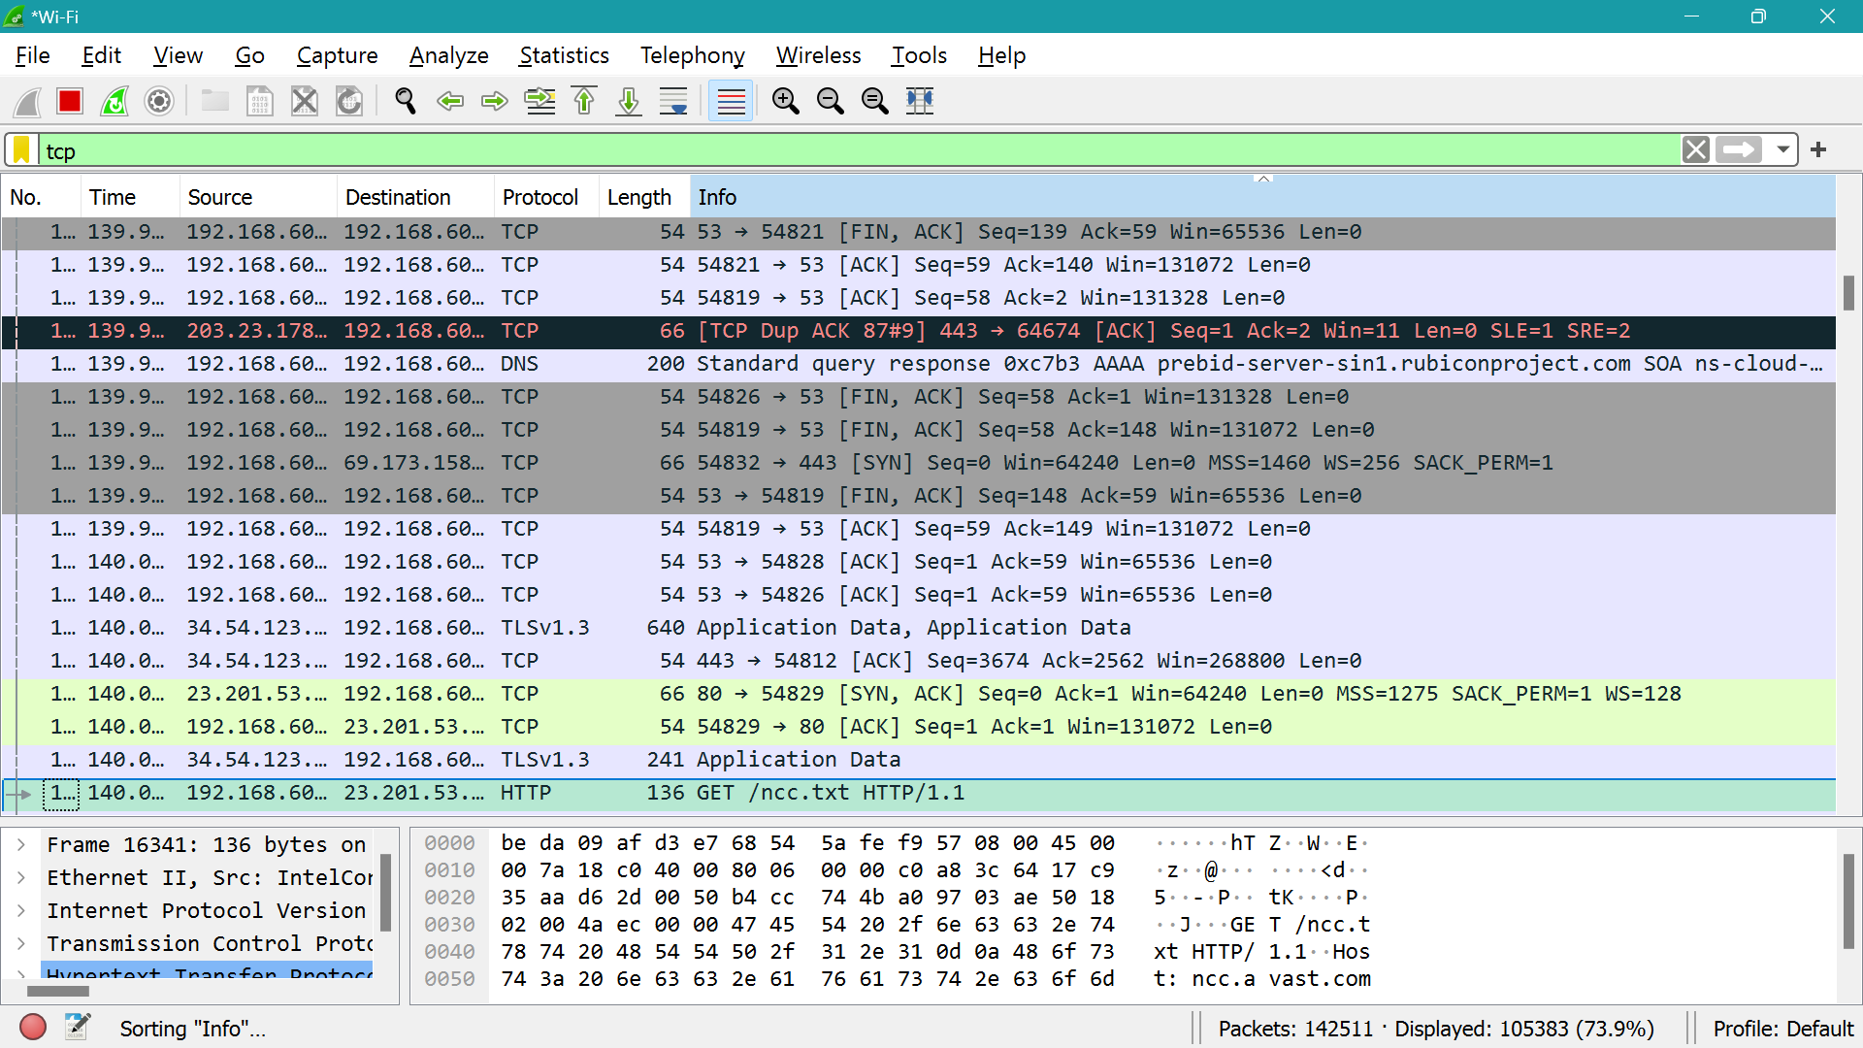

**Result:**

Hence, the capturing of packets using wire shark network analyzer was analyzed for TCP.

**EXPERIMENT 10**

**TRANSPORT LAYER PROTOCOL HEADER ANALYSIS USING WIRESHARK-DNS**

**Aim:** To analyze capturing of Transport layer protocol header analysis using Wire shark- DNS.

**SOFTWARE USED:** Wire shark network analyzer

**Procedure:**

1. Open wire shark.
2. Click on list the available capture interface.
3. Choose the wifi interface.
4. Click on the start button.
5. Active packets will be displayed.
6. Capture the packets & select any IP address from the source.
7. Click on the expression and select IPV4 →IP address source address in the field name.
8. Select the double equals (==) from the selection and enter the selected IP source address.
9. Click on the apply button.
10. All the packets will be filtered using the source address.

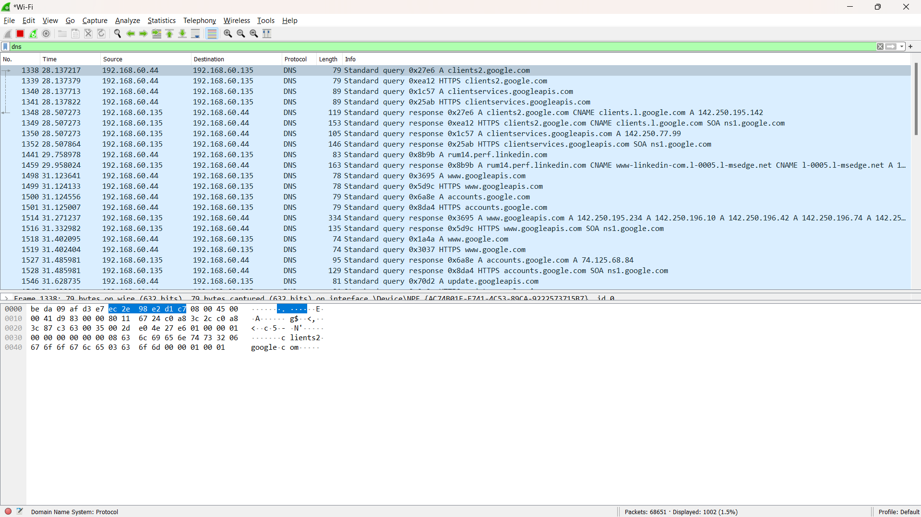

**Result:**

Hence, the capturing of packets using wire shark network analyzer was analyzed for DNS.

**EXPERIMENT 11**

**TRANSPORT LAYER PROTOCOL HEADER ANALYSIS USING WIRESHARK-HTTP**

**Aim:** To analyze capturing of Transport layer protocol header analysis using Wire shark- HTTP.

**SOFTWARE USED:** Wire shark network analyzer

**Procedure:**

1. Open wire shark.
2. Click on list the available capture interface.
3. Choose the wifi interface.
4. Click on the start button.
5. Active packets will be displayed.
6. Capture the packets & select any IP address from the source.
7. Click on the expression and select IPV4 →IP address source address in the field name.
8. Select the double equals (==) from the selection and enter the selected IP source address.
9. Click on the apply button.
10. All the packets will be filtered using the source address.

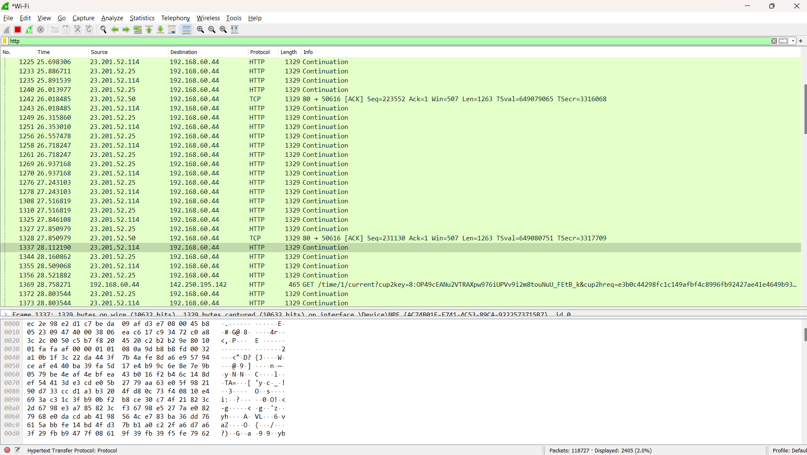

**Result:**

Hence, the capturing of packets using wire shark network analyzer was analyzed for HTTP.

**EXPERIMENT 12**

**Identifying Hidden Processes and terminate processes**

**Aim:** To Identify Hidden Processes and terminate processes.

**SOFTWARE USED:** CMD prompt.

**Procedure:**

1. Open cmd with run as administrator.
2. List all running processes:

**tasklist**

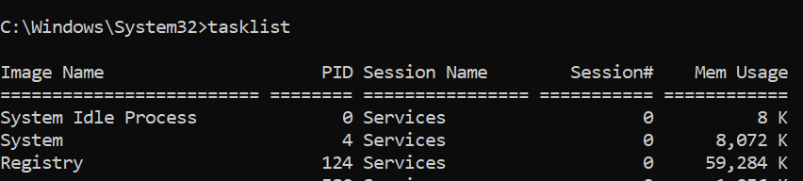

1. The above command will list all running tasks.
2. now run the below command to list all the hidden tasks

***wmic process where "SessionId=0" get Name, ProcessId***

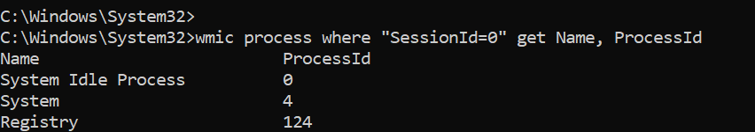

1. The above command will list all running hidden tasks.
2. to terminate any running task run the below command

***taskkill /F /PID <PID_NUMBER>***

1. The Pid_number should be the ID of the process.

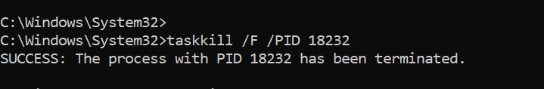

**Result:**

Hence, the termination of the running process can be executed successfully.

**EXPERIMENT 13**

**Hiding a ZIP File Inside an Image**

**Aim:** To Hide a ZIP File Inside an Image.

**SOFTWARE USED:** CMD prompt.

**Procedure:**

1. Place the image file (cover.jpg) and ZIP file (secret.zip) in the same folder.
2. Open cmd inside the folder.
3. Run the following cmd

**copy /b cover.jpg + secret.zip hidden.jpg**

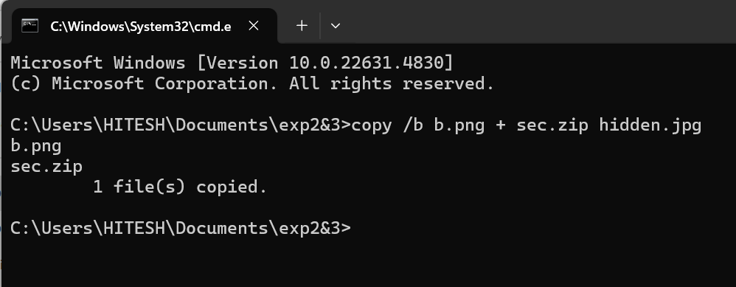

1. hidden.jpg will look like a normal image but contains the hidden ZIP file.
2. To view the hidden file run the below cmd

***ren hidden.jpg secret.zip***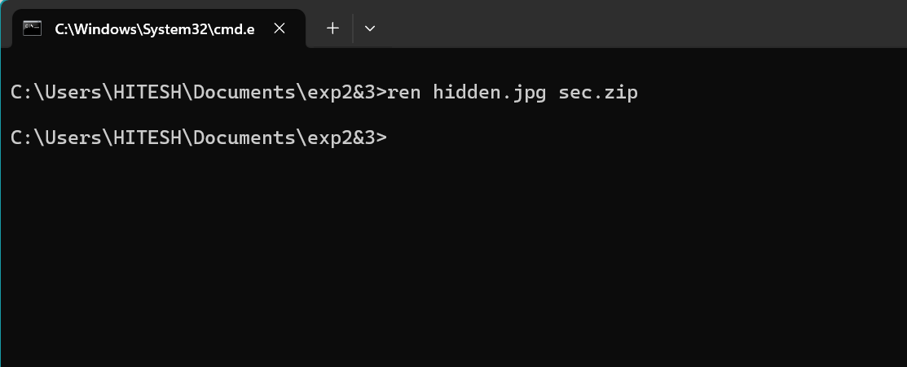

1. After the above cmd the hidden file will be restored.

**Result:**

Hence, hiding the file command executed successfully.

**EXPERIMENT 14**

**View All Wi-Fi Passwords Saved on the Computer**

**Aim:** To View All Wi-Fi Passwords Saved on the Computer.

**SOFTWARE USED:** CMD prompt.

**Procedure:**

1. Open Command prompt as administrator
2. Run below command to see all saved Wi-Fi networks

**netsh wlan show profiles**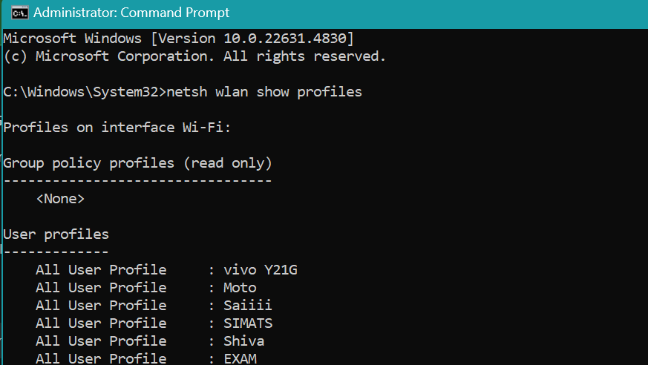

1. To see the password for a specific Wi-Fi network, use below cmd

**netsh wlan show profile name="WiFi-Network-Name" key=clear**

1. Now the password of the desired password is found.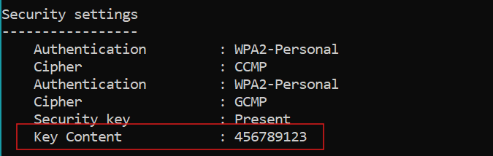

**Result:**

Hence, the password of the desired wifi is executed successfully.

**EXPERIMENT 15**

**To extract the recent login and logout**

**Aim:** To extract the recent login and logout

**SOFTWARE USED:** CMD prompt.

**Procedure:**

1. Open Command prompt as administrator
2. Run below command to see to recent logins

**wevtutil qe Security /q:"*[System[(EventID=4624)]]" /rd:true /c:10 /f:text**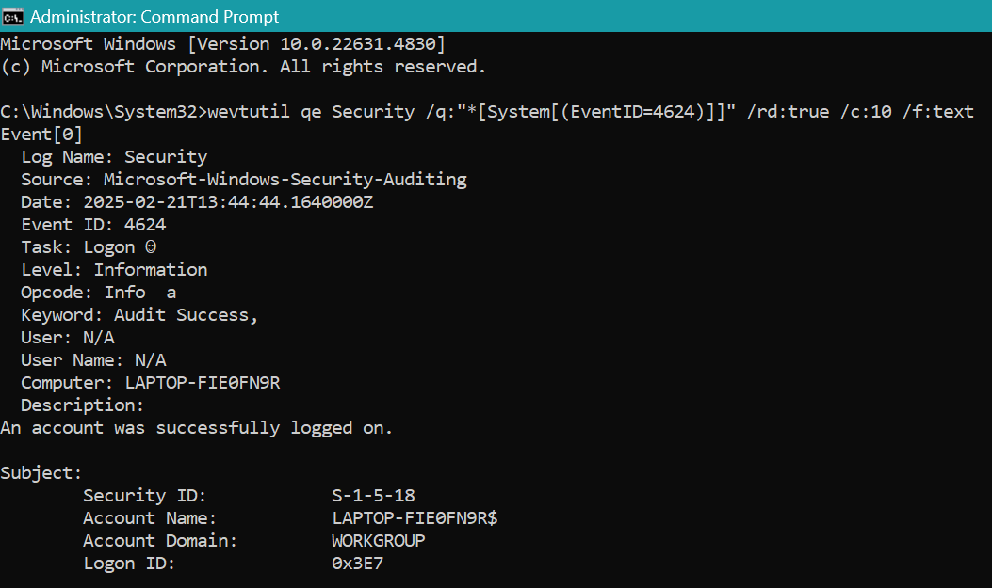

1. Run below command to see to recent logout

**wevtutil qe Security /q:"*[System[(EventID=4634)]]" /rd:true /c:10 /f:text**

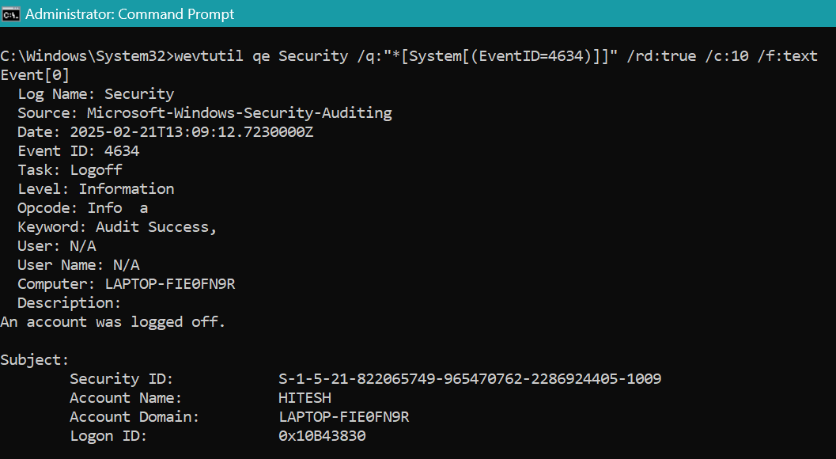

1. Now the last 10 logins and logouts can be found.

**Result:**

Hence, recent 10 login and logout can be extracted successfully .